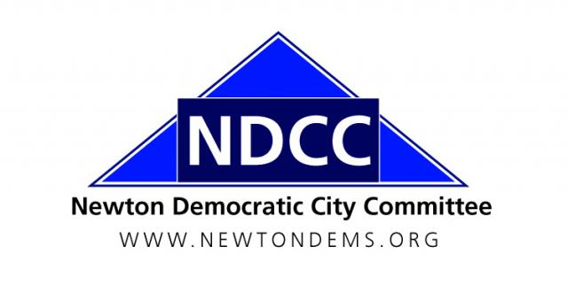

Women’s Workshop
Newton Highlands, MA 02461

NDCC General Meeting Minutes
3 December 2015

- Call to Order

A. Chair Shawn Fitzgibbons called the meeting to order at 7:30 p.m., at the Women’s Workshop, 72 Columbus Street, Newton Highlands. Attendance: 24

B. Attendance and Introductions

Executive Committee Members in Attendance: 17 (Shawn Fitzgibbons, Sharon Stout, Holly Ryan, Bryan Barash, Dan Clifford, Robert Fitzpatrick, Carol Fulton, Ted Gross, Larissa Hordynsky, Bill Humphrey, Martina Jackson, Barbara John, Don Ross, Margie Ross Decter, Bill Sage (via telephone), Caroline Schwarzwalder, Frank Wolpe)

Additional NDCC Members in Attendance: 6 (Marty Heyman (Ward 6), Jeannie Marcus (Ward 3), Rachel Ethier Rosenbaum (Ward 4), John Tener (Ward 6)

Guests: 1 (Patrick Beaudry, Mass. Dems Communications Director)

Note: NDCC Bylaws set a quorum at a general meeting at 31 or more voting members. A quorum lacking, no votes were taken on business matters at this meeting.

II. Minutes of the September 10, 2015 NDCC General Meeting

Secretary Robert Fitzpatrick reported that the Minutes had been circulated to the Executive Committee a week prior to the meeting. Additional hard copies were available for those who didn’t receive them. Due to the absence of a quorum no action was taken on the Minutes.

III. Reports of Officers and Ward and Standing Committees

- Treasurer’s Report (Bill Sage)
  - Expenditures totaled $63.75 in November, for MailChimp email marketing services.
  - There were no revenues, so the balance dropped from $12,849.26 to $12,785.51
  - Very little activity is anticipated in December, although we are expecting a $1,000 contribution from a Democratic supporter at the request of Congressman Kennedy. That would leave over $13,000 in the account at year’s end, a strong position heading into an election year.

- Ward Committee Reports
  - All wards submitted their slates to elect the new committees at the March 1 presidential primary. Those not on the slate can be elected as write-ins on that day, but need at least 5 votes (and must place in the top 35 vote-getters).

- State Committee Report (Sharon Stout)
  - The state committee met in Lee in November and set the caucus window to elect delegates to the state convention (June 4, 2016 in Lowell) from February 6 to April 4.
  - Ted Gross reported that the Democratic National Convention is in Philadelphia from July 25 to 28. Caucuses to elect national delegates from our Congressional district, based on the results of the March 1 presidential primary, will be held on Saturday, April 23, 2016.

- Presidential Campaign Updates
  - Rep. Joe Kennedy will be campaigning in Nashua for Hillary Clinton this weekend, as will Rep. Kay Khan. Carpool leaves from the Austin Street lot at 8:30 a.m. on Saturdays.
  - The Bernie Sanders campaign also is organizing canvasses in New Hampshire, leaving from Riverside station on Saturday mornings. Carol Fulton reported that there is a “NewtonMA4Bernie” Facebook page with information about volunteer opportunities.

- Thanks for Local Elections
  - Thanks to everyone who worked on Newton’s local elections this year, with particular thanks to Ald. Marcia Johnson for her years of service to Newton and to Ruth Dain, who worked tirelessly on the campaign and is now home sick.

IV. Announcements
- Charter Commission: Bryan Barash reported that the Newton Charter Commission will meet on the 2nd and 4th Wednesday of each month. The first meeting is Wednesday, December 9. The first public hearing will be on Thursday, December 17, at City Hall.
- NDCC Holiday Social: Shawn Fitzgibbons is hosting a holiday social at his home (300 Homer Street) on Sunday, December 20, at 4 p.m. Gather to catch up with friends and celebrate the coming new year.
- New NDCC Interns: Eric Joseph, a Mt. Ida College student, and Charlie Hiller, a Brandeis University student, are coming on board as NDCC interns. We are happy to have them.

V. New Business
- 2016 NDCC Budget (Bill Sage)
- The Finance Committee has a proposed 2016 budget, approved in November by the Executive Committee. Due to lack of quorum the budget proposal will be voted on in March. We will operate under the current budget until that time.
- The budget proposal for 2016 is similar to the 2015 budget, with an additional $5,000 budgeted in the Democratic Program & Action fund for a campaign headquarters. The budget also projects to an additional $5,000 in fundraising revenue, which could be given to the state party or spent directly by the NDCC.
- The proposed budget projects continued success with the Brunch, which in 2015 set a record for funds raised. Sharon Stout reported that 2015 Brunch expenditures were well under $2,000, about half of the $3,000 budgeted, thus improving the net result.
- Bill Sage said Sharon had done a fantastic job keeping expenditures low given that the venue costs $700, as compared to a free venue in a private home in years past. Retaining the $3,000 expenditure target for the Brunch will give us plenty of leeway.
VI. Adjournment

Motion: Carol Fulton moved to adjourn, Frank Wolpe seconded the motion. Adjourned: 8:21 p.m.

The business meeting was followed by a presentation from Pat Beaudry, Communications Director of the Massachusetts Democratic Party, and a question-and-answer session.

Respectfully Submitted,
Robert K. Fitzpatrick
Secretary, NDCC

