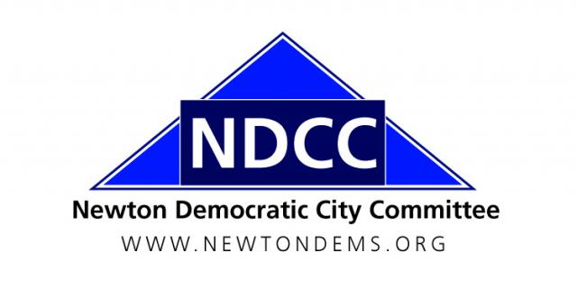

Women’s Workshop
Newton Highlands, MA 02461

NDCC General Meeting Minutes
1 December 2016

- Call to Order

- Chair Shawn Fitzgibbons called the meeting to order at 7:30 p.m., at the Women’s Workshop, 72 Columbus Street, Newton Highlands. Attendance: 150 to 200.

B. Attendance and Introductions

Following the unfortunate 2016 election result an overflow crowd showed up to this meeting, making an accurate attendance tally impossible. A more reliable sign-in system is being devised for future general meetings.

II. Minutes of the September 15, 2016 NDCC General Meeting

Motion: Frank Wolpe moved, Bryan Barash seconded the motion, to approve the minutes of the Sept. 15, 2016 general meeting as distributed. Motion passed, no votes against, no abstentions.

III. Reports of Officers and Ward and Standing Committees

- Treasurer’s Report (Sue Fliegel)
  - November was a quiet month, with $59.50 spent for MailChimp email services and no revenue.

- 2016 Election Recap
  - A lengthy discussion took place, with many attendees wishing to share their thoughts on the election. Among the points raised were:
- Rep. Ruth Balser: The election is deeply troubling but we must keep working. Efforts of MA volunteers led to victory in N.H. We should consider adopting a “sister” swing district to have similar impact in future elections.
- Martina Jackson: MA Together We Can, an organization coming out of the Clinton campaign, met last week to organize. The group is working on the Louisiana U.S. Senate race, sending a contingent to the Jan. 21 march in Washington, and will be active on other important campaigns.
- David Albright: The loss was shocking and still hurts, but our values remain majority values. We must keep working to promote them. Many Latino citizens not well served by gov’t. We must register them to vote and work hard to turn them out.
- Clint Keaveney (BC Dems): As hard as it is to see the positive now, younger voters overwhelmingly supported Hillary and are getting more engaged by the day. There has been a huge upsurge in interest and activism in response to the election.
- Bob Jampol: What went wrong? 5 Newton city workers told him they were voting Trump. Newton is no different than the Rust Belt: Trump somehow claimed the mantle of populism and we have to reclaim it.
- David Cohen: “I am now a born-again activist.” We have to fight unflinchingly against bad proposals to protect people who will be hurt. Democrats won a majority of votes and must act like it and mobilize.
- Marty Heyman: We must put this in historical context and realize that change happens from the grassroots up. Organize locally, make positive changes at the local and state level, build a movement, and eventually win in DC as well.
- Jean Roper: We need to communicate better. Trump managed to fool a lot of voters into thinking he’ll help them but the Republicans have no intention of helping.
- Sen. Cindy Creem: Since the election the Democrats have come to life and the state level will be the place for positive change for the next few years. We need to reach people who think, “D or R, it doesn’t matter,” and focus on creating good jobs while not turning our backs on vulnerable populations. Sen. Creem also is sponsoring the Trust Act in the state legislature.

- How to Get Involved
  - Those interested should contact Shawn Fitzgibbons about joining their local ward committee. People also can sign up for our email list to get regular action alerts.
  - Martina Jackson is signing people up for the march in Washington on January 21. The Newton Dems will send a contingent to the Boston march as well.
  - Sharon Stout said the state party will be holding regional meetings to go over the election and regroup. One should be held in Newton (or nearby) in January. The state party also just elected a new chair, Gus Bickford, and soon will hire a new Executive Director. There is a lot of new energy and people can always reach out to local Dems or their DSC members.
  - Holly Ryan noted local elections are coming in 2017 and said we should have progressive Democratic candidates for all seats. Holly added that she is one of the two openly transgender members of the DSC; a ballot question to repeal the antidiscrimination protections she fought years for will be on the 2018 ballot and must be defeated.
  - We continue to work for the Newton school custodians to get a fair deal, and there will be ballot questions on the Fair Share Tax and the minimum wage in 2018.

- Immigration Policy and Newton as a Sanctuary City (Paul Glickman and Sue Parsons)
  - Immigration attorney Paul Glickman and Sue Parsons of Mass. Immigrant and Refugee Advocacy Coalition (MIRA) presented on immigration policy and what we can do.
  - Since the election MIRA is getting over 100 panicked calls a day. The Obama administration deported many undocumented immigrants but settled on a policy of targeting those who were committing serious crimes, not predawn raids of law-abiding families. The incoming administration is expected to be much more draconian.
  - Paul raised the idea of Newton becoming a “sanctuary city.” There is no official definition, but generally it means local resources won’t be used to do ICE’s work for it. Knowing local authorities won’t hold them for ICE makes immigrants more willing to report crimes, etc. Newton City Councilors, including Susan Albright, are interested in an ordinance here.

Motion: Bryan Barash moved, Barbara John seconded the motion, that the NDCC endorse Newton becoming a sanctuary city. Motion passed, no votes against, no abstentions.

- NDCC “Change Committee” (Priscilla Leith)
  - Priscilla is forming a committee to investigate what went wrong in the elections and where the Democratic Party goes from here. The committee’s findings are to be reported to the DNC. All interested in participating should contact Priscilla.

V. Adjournment

Motion: Carol Fulton moved to adjourn, Dmitriy Gridnev seconded the motion. Adjourned: 9:18 p.m.

Respectfully Submitted,
Robert K. Fitzpatrick
Secretary, NDCC

