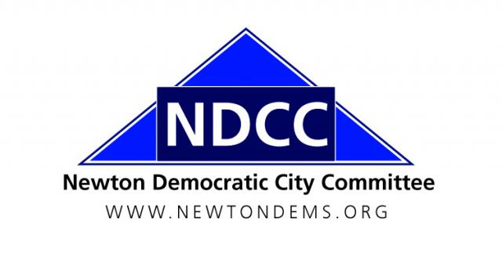

Women’s Workshop
Newton Highlands, MA 02461

NDCC General Meeting Minutes
2 March 2017

- Call to Order

- Chair Shawn Fitzgibbons called the meeting to order at 7:25 p.m., at the Druker Auditorium, Newton Free Library. Attendance: 100+.

B. Executive Committee Attendance: 25. Shawn Fitzgibbons, Sharon Stout, Holly Ryan, David Albright, Bryan Barash, Rep. Ruth Balser, Dan Clifford, Allan Cole, Audrey Cooper, Susan Davidoff, Robert Fitzpatrick, Sue Fliegel, Carol Fulton, Dmitriy Gridnev, Ted Gross, Larissa Hordynsky, Bill Humphrey, Martina Jackson, Barbara John, Rep. Kay Khan, Ken Krems, Priscilla Leith, Emily Prenner, Caroline Schwarzwalder, Frank Wolpe.

II. Minutes of the December 1, 2016 NDCC General Meeting

Motion: Frank Wolpe moved, Bill Humphrey seconded the motion, to approve the minutes of the Dec. 1, 2016 general meeting as distributed. Motion passed, no votes against, no abstentions.

III. Reports of Officers and Ward and Standing Committees

- Caucus and Convention
  - Martina Jackson: The 2017 state Democratic convention is a platform convention. The Platform Committee will hold open hearings around the state. Testify to influence the platform.
  - Sharon Stout: The convention is Saturday, June 3. Newton’s 8 wards will hold caucuses to elect delegates on Sunday, March 19, at Newton South High School at 4 p.m.
  - There will be an activist training workshop at Newton South prior to the caucus, starting at 12:30.

- NDCC Issue Update
  - Welcoming City Ordinance: Councilors Susan Albright and Deb Crossley presented on the new city ordinance, endorsed by the NDCC at the Dec. 1 meeting and passed by the City Council 16-1. Councilor Albright: NDCC activists made it happen; about 1,000 emails in favor were sent.
  - Accessory Apartments: Councilors Albright and Crossley distributed a handout about this proposed ordinance to be taken up by the council in March. Priscilla Leith encouraged supporters in Ward 7 to contact the Ward 7 councilors in particular.
  - Newton School Custodians: The NDCC has opposed strongly outsourcing the custodians’ jobs. The School Committee is divided on this issue and should be contacted.
  - “Conversion Therapy” Ban: Rep. Kay Khan is supporting a bill to ban “conversion therapy” for LGBT minors. Holly Ryan recently was appointed to the commission fighting for this change.

- “Sister District” Proposal (Rep. Ruth Balser)
  - Rep. Balser followed up on an idea she proposed in December: that we “adopt” a swing Congressional district. Rep. Balser and Lauren Myers did research into districts and newly coordinated efforts and proposed working in the Maine 2nd- the nearest Republican-held seat to us.

- Charter Commission Debate
  - Charter Commission Chair Josh Krintzman spoke about the commission’s process and encouraged people to vote in favor of the new city charter proposal that goes before the voters in November.
  - The proposal would reduce the City Council to 12 members from 24. 1 councilor would be elected at large from each ward, and another 4 elected at large in a pool. Term limits for consecutive service would be added for the council (16 years) and the mayor (12 years).
  - In 3 minutes of remarks, Ward 7 City Councilor Marc Laredo urged a “no” vote:
    - An all at-large council will be less responsive to voters;
    - Having to run citywide will deter some worthy new candidates;
    - The proposal leaves the possibility that 5 of 12 councilors will come from one ward.
  - In 3 minutes of remarks, Rob Gifford urged a “yes” vote:
    - The current system is too complicated for less-informed voters, council hearings run too late;
    - At-large councilors are just as responsive to ward residents as ward councilors in many cases;
    - Residency requirements ensure geographic diversity, but all would have a citywide perspective.

- No on 2018 Transgender Rights Repeal Ballot Question
  - In October 2016 the Executive Committee voted to recommend opposing a 2018 ballot question that would seek to repeal the public accommodations bill for transgender people passed last June.
  - Holly Ryan said it would take away civil rights she and others long fought for and just won, and would make Massachusetts just like North Carolina.

Motion: Frank Wolpe moved, Dmitriy Gridnev seconded the motion, that the NDCC endorse a “No” vote on any 2018 state ballot question seeking to repeal rights for transgender people. Motion passed, no votes against, no abstentions.

- NDCC “Resistance Resolution” (Bill Humphrey)
  - Bill proposed a resolution urging our representatives to support a series of bills in Congress.
  - Virginia Ewell did not agree with some items; Bill said it came from the Democratic platform.
  - Rep. Ruth Balser said that we want to encourage action, but should take more time to discuss and revise the resolution before voting.

Motion: Frank Wolpe moved, Dmitriy Gridnev seconded the motion, to table discussion of the proposed “Resistance Resolution” until the June general meeting. Motion passed, 3 votes against, no abstentions.

- Safe Communities Act
  - The Executive Committee voted in February to recommend endorsing the statewide Safe Communities Act, which would prevent state and local employees from detaining people for immigration purposes except in certain delineated circumstances.

Motion: Martina Jackson moved, Bryan Barash seconded the motion, that the NDCC endorse passage of the Safe Communities Act in the state legislature. Motion passed, no votes against, one abstention.

V. Adjournment

Motion: Martina Jackson moved to adjourn, Carol Fulton seconded the motion. Adjourned: 8:48 p.m.

Respectfully Submitted,
Robert K. Fitzpatrick
Secretary, NDCC

